Adeo Home Services Methods

Object | AHS Execution Procedure
Expertise line | Business | Owner | Richie PERMAL
Status method | Validated / Inactive | Date version | 01/04/2025
Confidentiality level |  | No Restriction
Related Documents | - VSOP Execution  - Stream Plan Execution  - SOP User Guide  - [DRAFT] ADEO - EXEC - Playbook  - [DRAFT] Maturity Assessment - Towards 2028 - Execution  - [DRAFT] ADEO - EXECUTION - GO TO MARKET TEMPLATE

Glossary
1. SCOPE
2. APPLICATION FIELD
3. ROLES ET RESPONSIBILITIES
4. ACTIVITIES DESCRIPTION
4.1 Organize the Execution
4.1.1 SIPOC
4.1.2 Workflow
4.1.3 Key Process Indicator & target
4.2 Find a Pro
4.2.1 SIPOC
4.2.2 Workflow
4.2.3 Key Process Indicator
4.3 Orchestrate the execution
4.3.1 SIPOC
4.3.2 Workflow
4.3.3 Key Process Indicator
4.4 Perform the Execution
4.4.1 SIPOC
4.4.2 Workflow
4.4.3 Key Process Indicator
4.5 Manage Feedback
4.5.1 SIPOC
4.5.2 Workflow
4.5.3 Key Process Indicator
4.6 Invoice and Pay the Provider
4.6.1 SIPOC
4.6.2 Workflow
4.6.3 Key Process Indicator
4.7 Manage Claim
4.7.1 SIPOC
4.7.2 Workflow
4.7.3 Key Process Indicator
4.8 Track and Supervize the execution
4.8.1 SIPOC
4.8.2 Workflow
4.8.3 Key Process Indicator
4.9 Support and Manage Issues and Incidents
4.9.1 SIPOC
4.9.2 Workflow
4.9.3 Key Process Indicator
5. CONTINUOUS IMPROVEMENT
5.1 Business Improvement request
5.2 Continuous improvement process
6. ASSOCIATED DOCUMENTS

Glossary
Service Execution : Sx
Project Execution : Px
Happy case : Execution where all the steps are running without any manual gesture, automatisation is a success.
Unhappy case : Execution where an event comes to disturb the execution chain : failed automatic distribution, reschedule, reassignment, rework…

1. SCOPE
This procedure is dedicated to describe the Execution Business Activities of Adeo Home Services. Including :
- The roles and responsibilities that intervene during the different step of the execution
- The Business Activities description with :
  - The metroline
  - The SIPOC : Supplier, Input, Process, Output and Customer
  - The workflows and journeys
- The key process indicators and Objectives and Key Results
- The associated documents
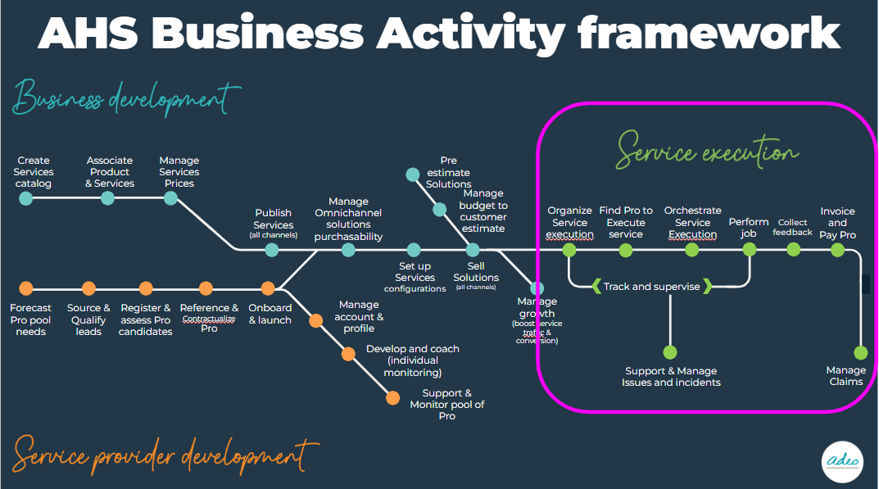

2. APPLICATION FIELD
The application fields of this procedure covers the following types of services :
- Commoditized service (forfait)
- Non commoditized service : technical visit + installation
This procedure does not cover yet :
- Technical visit of confirmation
- Complex project management : managed with several provider

DETAILLER TV / INSTALLA

3. ROLES ET RESPONSIBILITIES
The roles and responsibilities to execute the Services are defined below :
- Customer : the final role who benefits from an installation in house
- Seller :
  - Service Sales Editor : rôle of the store, in touch with the Customer, in charge to sell the service, release the order, manage the quotation, plan the first intervention and contractualize with the Customer.
  - Service sales Viewer : read only access on the task managed by the Service Sales Editor
- Execution Operator
  - Service Execution Admin : in charge to supervise the execution and operate some admin tasks if necessary. He has all the rights of the seller + of the Service execution editor. He can as admin :
    - Skip the contract signature
    - Insert extra cost over a limit defined by the Business Unit .
  - Service Execution Editor : in charge of all the execution tasks from the assignment of the provider in case of failure of the automatic assignment, orchestrate the execution, support and Monitor the execution by managing the tasks generated by the system or the request of Provider and customer before, during and after the execution.
  - Service execution viewer read only access on the task managed by the Service Sales Editor
- Provider : realize the job ordered by the Customer and subcontracted or intermediated by Adeo Home Services

4. ACTIVITIES DESCRIPTION

4.1 Organize the Execution
This business activity is dedicated to cover the following step :
- The integration of the sales order
- The planification of the service execution
- The signature of the Customer contract

4.1.1 SIPOC
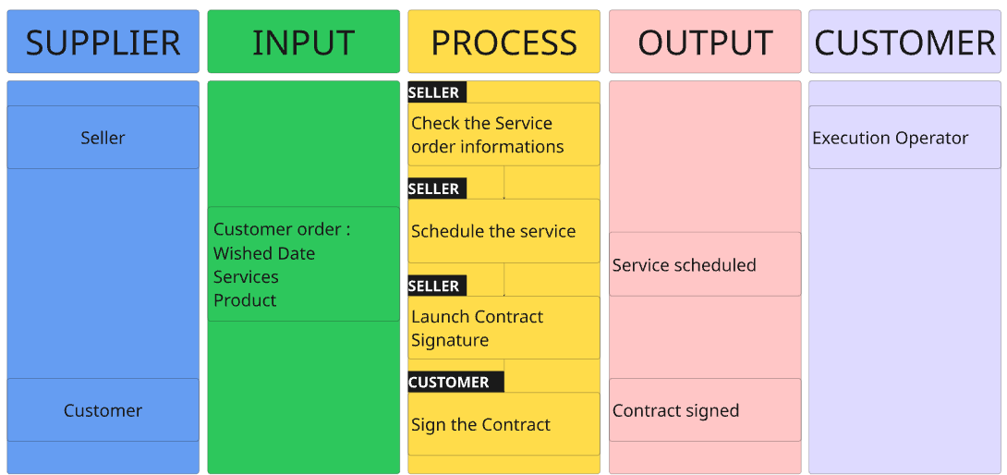

4.1.2 Workflow
- Scheduling workflow ⇒ TO CHECK / CREATE MIRO
  - This process must be defined in interdependency of the Sales team and Execution teams
  - Operating mode : SALES OPERATOR (SELLER)
    - Initiate the order according to the Customer expectations
    - Check/Confirm Worksite address and contact
    - Check availability of the Provider according to the first potential date for a service only and according to the delivery date for service + Products.
    - Close the order with the installation date according to service execution potential date

  - If needed, update the schedule date.

- Contract signature workflow
  - Operating mode : SALES OPERATOR (SELLER)
    - Define with the Customer the expected signature method : QR Code, email, paper (QR Code is highly recommended)
    - Submit the contract to sign to the customer
    - Get the contract signed by the customer
    - If paper, register the contract digitally
    - Monitor the contract signature (process to define between sales and execution teams) through :
      - data visualization : SALES OPERATOR animation https://app.powerbi.com/groups/d48c8d15-6540-49ff-a66c-47ac76d76330/reports/282bf4c6-4dc7-4626-b0c6-d6e76102ca2a/ReportSection784dbc7f6aa4486abc61?experience=power-bi&language=en-US
      - ZENDESK : EXECUTION OPERATOR https://adeohomeservices.zendesk.com/agent/filters/27831579721873

4.1.3 Key Process Indicator & target
- % of contract signed : over 99%
- Lead time of contract signature 90% in 10 minutes after Service execution creation
- % of contract signed by QR Code / Paper version / email : 70/20/10

4.2 Find a Pro
This business activity covers :
- The automatic assignment of the Provider to the work order
- In unhappy cases : The management of the failure of the automatic distribution

It exists 2 methodology to assign a Pro :
- Acceptation/Refusal : STANDARD PLATFORM Assignment
The pro is able to accept or refuse the assignment
The pro can accept under condition of rescheduling the job
The offer expires after a delay if the pro does not answer.

- Direct assignment
The Pro is directly assigned to the job, he cannot refuse or let expire the job

4.2.1 SIPOC
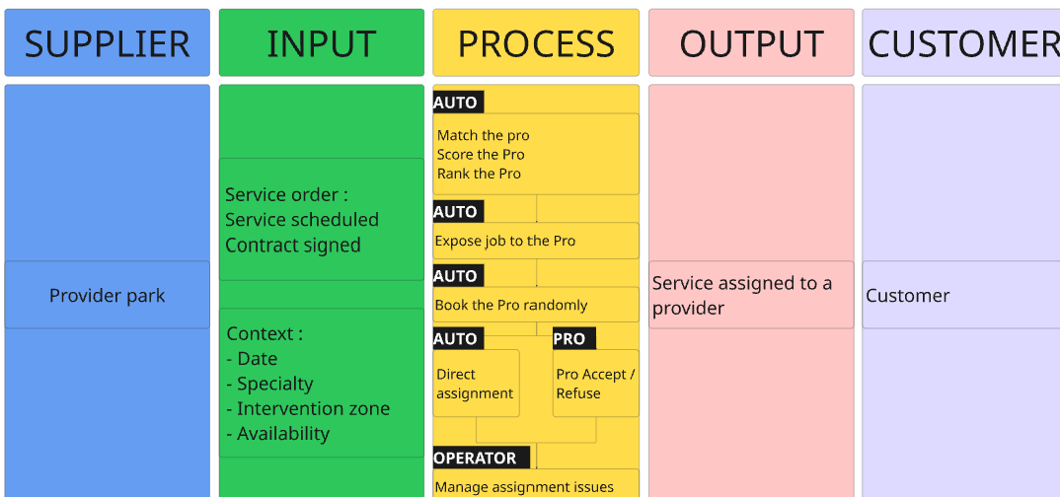

4.2.2 Workflow
- Automatic and manual assignment workflow
  - Manual Matching operating mode : EXECUTION OPERATOR
    - Analyse the failed automatic assignment
    - Identify the root cause of the assignment
    - Identify a Pro to assign according to the context of the Service Execution
    - If needed derogate to the context on the date.
    - Assign manually the pro needed
- Solve Assignment issues ⇒ TO CHECK / CREATE MIRO
  - Operating mode : Execution operator
    - Open the ticket received in ZENDESK
    - Identify the root cause of the automatic assignment failed
    - Manage manual assignment in SOP

4.2.3 Key Process Indicator
- Automatic distribution rate > 70% in accept/refuse assignment
- Automatic assignment rate > 90% in Direct assignment
- Ticket managed > 2 days
- Deep dive of Find a pro activity is accessible HERE

4.3 Orchestrate the execution
This business activity covers :
- The follow up and the action plan linked to the payment of the order before the starting of the execution
- The follow up and the action plan linked to the delivery of the products of the order before the starting of the execution
- The action plan linked to the Orchestration events :
  - Cancellation of the job by the provider assigned leads to a manual assignment management
  - Inbound of the Customer or Provider can lead to :
    - Cancellation request (can be also requested by the seller)
    - Reschedule request
    - Reassignement of the Job
- Request of extra cost by the Provider

4.3.1 SIPOC
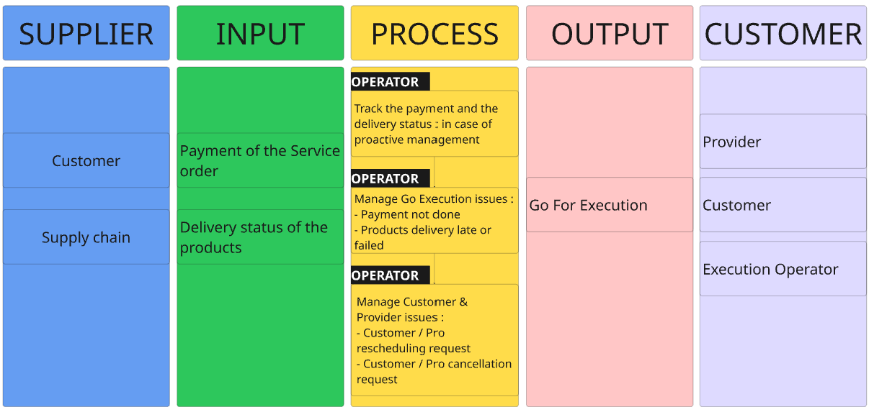

4.3.2 Workflow
- Workflow of proactive tracking = Local = MIRO
  - Set your local policy for preventive management on payment and delivery
- Workflow Go Execution = MIRO
  - Payment issue management operating mode : OPERATOR EXECUTION
    - Get a task generated for the payment issue X days before job starting
    - Manage the task in ZENDESK and collect information
    - Animate the collect of the payment or get cancellation request : operating mode to define with the SALES OPERATOR
    - Manage the Sx or cancel
  - Delivery issue management operating mode : OPERATOR EXECUTION
    - Get a task generated for the delivery issue X days before job starting
    - Manage the task in ZENDESK and collect information
    - Animate the delivery/product change or reschedule or cancellation : operating mode to define with the SALES OPERATOR / SUPPLY CHAIN
    - Manage the Sx or reschedule or cancel

- Workflow : Manage Customer and Provider issues :
  - Cancellation workflow
  - Rescheduling workflow

4.3.3 Key Process Indicator
- Deep dive of Orchestration activity is accessible HERE
- Cancellation rate : < 10%
- Rescheduling rate : < 10%

4.4 Perform the Execution
This business activity covers :
- The starting of the job by the provider
- The end of the job by the provider
- The process of management of the work closing job when the Provider declares the end of the job
- For the unhappy flow case, this activity can integrate the action of pause of the Provider that leads to the reassignment and the reschedule of the Provider.

Different types of Services are executed :
Commoditized | Non commoditized | Sales with Estimation | Claim
Installation | Technical visit  Installation after technical visit | Technical visit linked to pre-estimation  Installation linked to pre-estimation | Rework

4.4.1 SIPOC
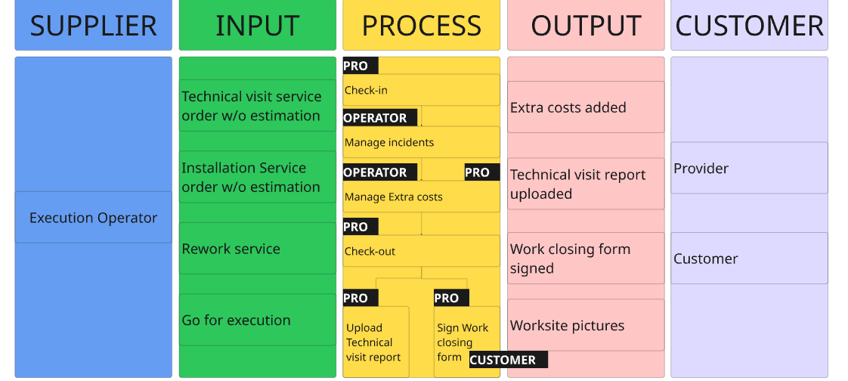

Currently, the Technical visit process is followed by the Quotation process dedicated to :
- track the creation and the sending of the customer quotation
- inform about the acceptance/refusal of the customer quotation
Those actions are tracked by waiting for the creation of the process by the Global Sales team.

4.4.2 Workflow
- Workflow Perform the job MIRO
  - Quotation (Technical visit) Operating mode
    - Pro starts the Technical visit by check in and pictures
    - Pro performs the Technical visit
    - Pro checks-out the Technical visit
    - Pro sends the report according to the defined standard
    - Report is collected, checks
    - Quotation is prepared by the SALES OPERATOR or EXECUTION OPERATOR
    - Quotation is introduced to the customer by the SALES OPERATOR
    - Status of validation of the quotation is registered by the SALES OPERATOR in SOP
  - Installation Operation Mode
    - Pro starts the Installation by checking all the material on site and the worksite conditions
    - Pro does the check in and pictures
    - Pro does the installation
    - Pro checks-out the installation and controls the job.
    - If the pro signs the work closing form, he initiates the document : Email submission is recommended, paper version is accessible
    - The Customer signs the Work closing form, with or without reserves.
    - In case of paper work closing form, the Pro sends the document to the Operator
    - The Operator uploads the document in SOP and register the reserves

  - Confirmation Technical visit Operating mode

- Workflow of Work Closing Form signature CAMUNDA
- Workflow Work Closing form not signed : Here
- Workflow Work Closing signed with reserves : Here

  - Rework Operating mode ?

- Workflow Manage Incidents MIRO
  - Impossible to start operating mode
    - Product broken
    - Customer no show
    - Missing Product
    - Worksite not accessible
  - Execution incidents - Pause
    - Product broken
    - Missing Product

- Workflow Manage Extra costs MIRO
  - Extra cost operating mode
    - Define the extra cost procedure for validation flow, authorization and amount limit
    - Receive extra cost request from the provider
    - Analyse and validate the request : internal process of validation according to the amount
    - Request customer payment if needed
    - Animate the Extra cost and capitalize to reduce the inbound and amount.

4.4.3 Key Process Indicator
- Quotation Alerts follow up
- Orchestration Deep Dive
- Installation not started rate < 5% / Root causes repartition
- Pause rate / Root causes repartition : < 3%
- Leadtime of Work closing form signature : 90% less than 10 minutes
- Type of Work closing form Process : 90% digital
- % of reserves on Work closing form : < 10%
- On time in full rate : 80%
- Extra costs tracking : < 20% in volume

4.5 Manage Feedback
This Business Activity covers the collection of the feedbacks from the persona :
- Customer
- Execution Operator
- Seller
This Activity is critical to measure the level of satisfaction of our stakeholders and set up action plans to continuously improve the satisfaction and the experience.

4.5.1 SIPOC
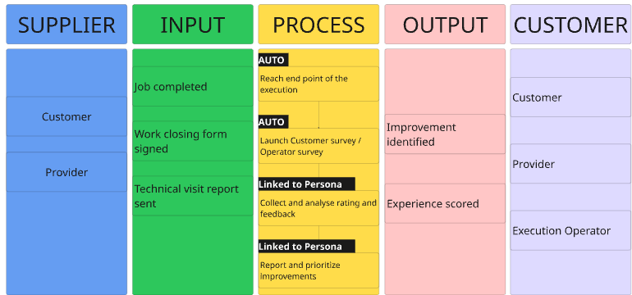

4.5.2 Workflow
- Workflow Customer Feedback TBD
  - Pro and Operator Survey operating mode : AHS CORPORATE
    - Define the survey purpose
    - Build the survey
    - Launch survey for Pro / Operator
    - Animate the completion of the survey : AHS CORP + LOCAL Business Unit
    - Collect and analyze the results
    - Define action plan : AHS CORP + LOCAL Business Unit

4.5.3 Key Process Indicator
- NPS Customer / NPS Operator
- Provider rating
- Customer Effort score for Customer and Operator

4.6 Invoice and Pay the Provider
This Business Activity is dedicated to invoice and pay the Provider for the Service Executed.
2 systems will be proposed to the providers :
- Self-billing process : Target
- Invoice submission process

The claim management is not yet implemented on this business activity and there are deviations according to the current systems that exist in the Business Unit.

4.6.1 SIPOC
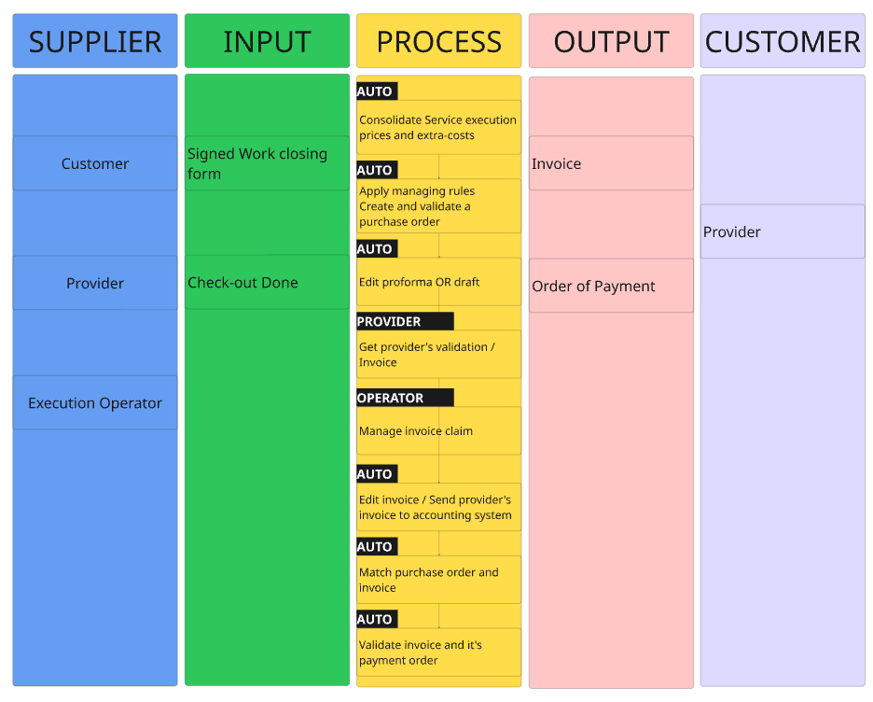

4.6.2 Workflow
Lien vers les workflows CAMUNDA + MIRO si non dispo

4.6.3 Key Process Indicator
- Part of the Provider with order of payment sent under 48h : > 70%
- Part of the Provider with order of payment sent between 48h and 7 days : >25%
- Pro inbound/claim on invoicing : < 5%

4.7 Manage Claim
This business activity is dedicated to managing all customer claims related to the installation, from the moment a claim is raised through to the resolution and closure.
The objective is to address issues efficiently, ensure timely resolution, and maintain a high level of customer satisfaction throughout the lifecycle of the installation

4.7.1 SIPOC
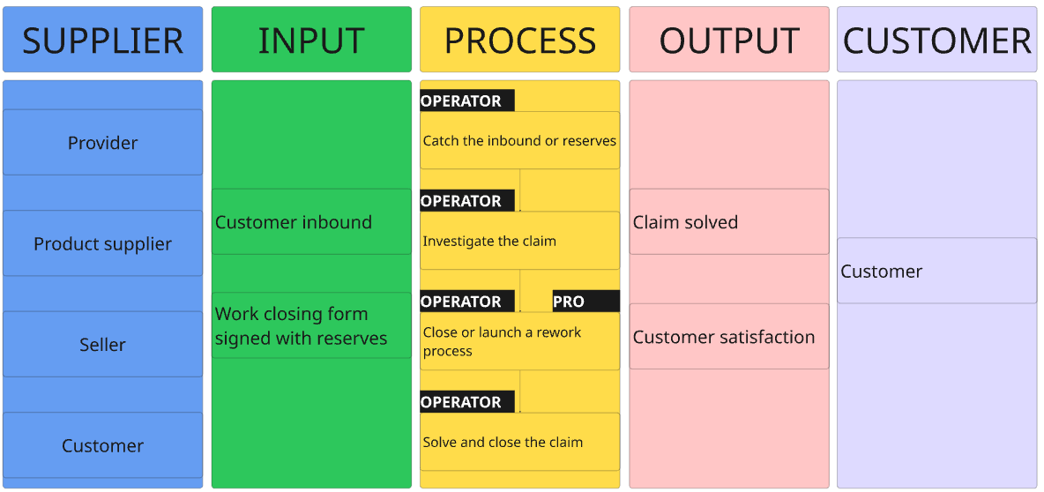

4.7.2 Workflow
- Rework flow
  - Claim management operating mode
    - Map the inbound of claims : end of the job or after the end of the job
    - Define the root cause analysis mode : tool, external partner, internal investigation
    - Define the internal control procedure
    - Manage the claim :
      - Compensation
      - Second visit
      - Rework
    - Solve the claim case

4.7.3 Key Process Indicator
- Claim rate : > 5%
- Claim costs
- Lead time to solve a claim
- Customer CSAT

4.8 Track and Supervize the execution
This Business Activity is dedicated to manage the efficiency of the Operations. On the basis of the funnel, we identify the leakage and bring continuous improvement on the Operations.
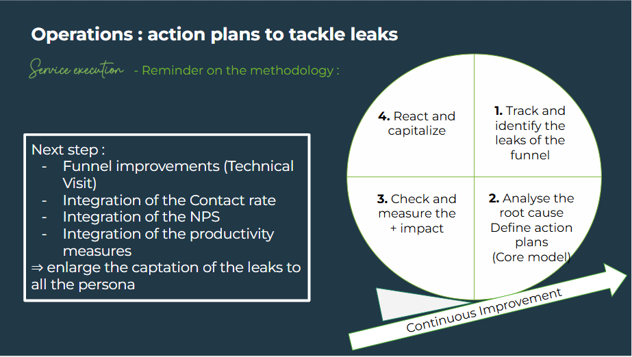

4.8.1 SIPOC
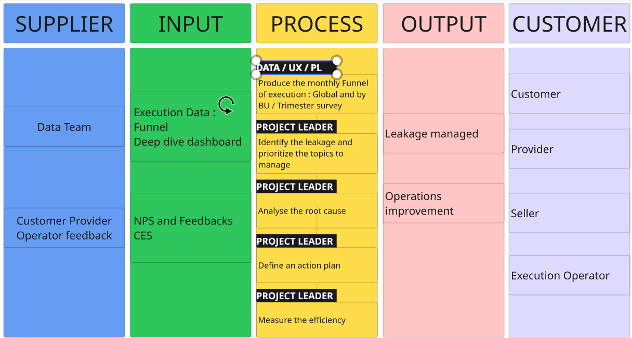

4.8.2 Workflow
- Workflows to create MIRO
  - Continuous improvement operating mode
    - Define the periodicity of the funnel review
    - Identify the main pain points to work
    - Cross check with the persona satisfaction score
    - Deep dive in root cause analysis
    - Define action plan local Business Unit / AHS Corporate
    - Measure the effect
    - Capitalize

4.8.3 Key Process Indicator
- Number of improvements implemented : 3/year
- Value creation of the improvement measured by the tactical KPIs
- Execution Funnel
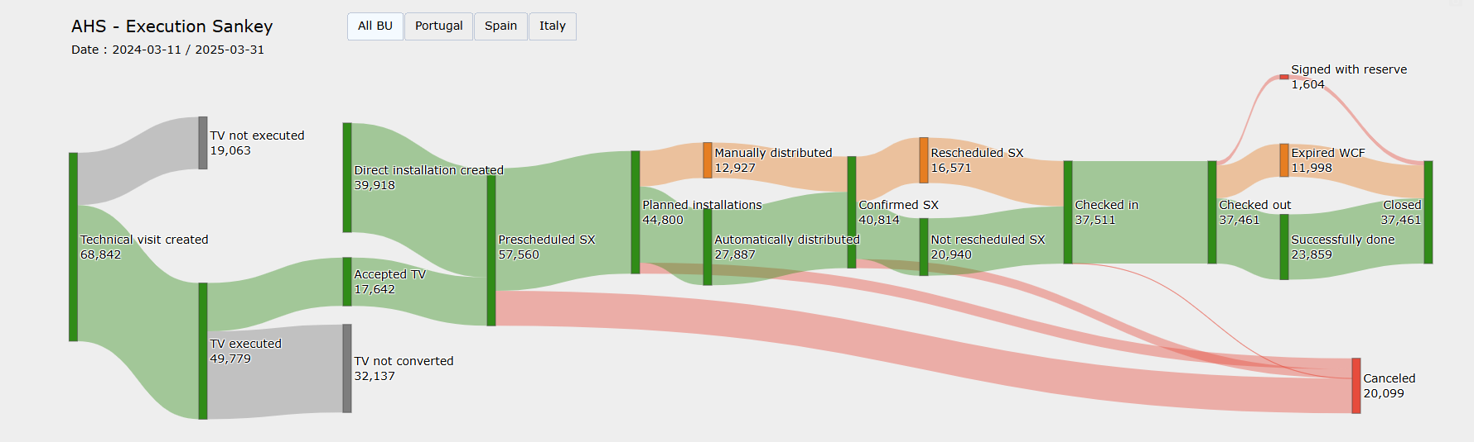

4.9 Support and Manage Issues and Incidents
Referential alerting
Processus de traitement

This Business Activity is dedicated to manage the issues : events that happened before the starting of the execution and the incidents : events that happened during the execution of the services.
The issues and incidents can be identified following :
- The task generated automatically by the system
- The inbounds from the Customer : transferred by the Customer Care, by form from the web account, transferred by the store
- The inbounds from the Provider : by Form (Helpcenter), phone call, in store
- The inbounds from the seller transferred to the Operators

Taxonomy of all the possible inbounds by type of contact, when it’s happening (before, during or after the installation), and where it is rooted in our ticketing tool:
Taxonomy inbounds Support & Manage issues and incidents

4.9.1 SIPOC
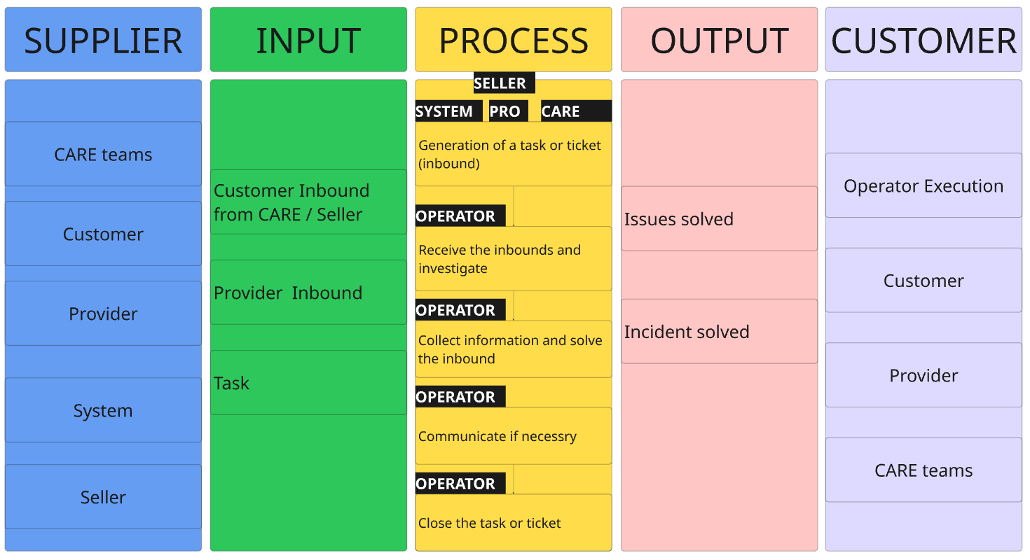

4.9.2 Workflow
Lien vers les workflows MIRO à créer

4.9.3 Key Process Indicator
- Customer contact rate < 10%
- Provider contact rate < 10%
- Repartition of root causes of inbounds
- Inbounds costs
- Lead time to solve issues and incidents

5. CONTINUOUS IMPROVEMENT

5.1 Business Improvement request
All the insights and proposals of improvement are collected through the Business improvement request file.
Each Business Unit Execution Member is responsible to feed the file with the improvement wish.
Those topics are reviewed and prioritized in the Stream Committee in a Core Model decision making model.

5.2 Continuous improvement process
Decision making model :
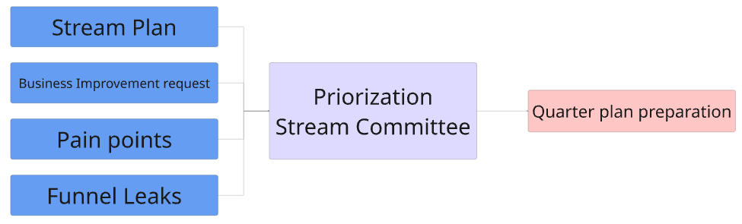

6. ASSOCIATED DOCUMENTS
- Contract template
- Formulaire de satisfaction client
- Invoice template
- …

